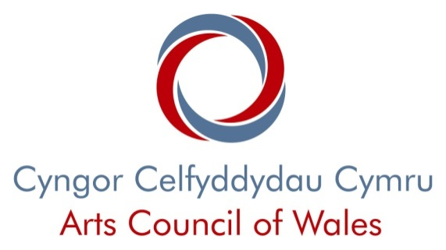

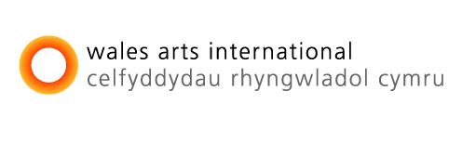

Creative Wales Ambassadors

Partner Nomination Form:

Wales Based Host Organisation
Wales based host organisation

About you

The contact person named here must be authorised to answer all queries and to sign all paperwork relating to this nomination form.

Organisation name:

Legal name (if different from above):

Contact person name:

Position in the organisation:

Organisation Address: | Address for correspondence  (if different from Organisation address)

Telephone number (day):

Telephone number (evening):

E-mail address (if available):

(We will use this e-mail address for correspondence about this nomination.)

Website address (if available):

Please indicate your preferred language of correspondence:

Welsh ◻

English ◻

Wales based host’s collaboration proposal

Please use this section to tell us about the collaboration between your organisation, the International host organisation and the nominated artist. Rather than answer a series of questions we ask you to write five statements. They aren’t listed in any order of priority, but they will form a major part of our assessment process.

Before you start writing your statements, please make sure that you have read and understood our Nomination Guidance & Essential Help Notes for Creative Wales Ambassadors.

The artistic vision and plans for the Creative Wales Ambassadors award

- Please tell us about the proposed collaboration in detail and describe the plans to explore and expand what you expect to achieve through this award.

The contribution to the Arts in Wales

- Please describe the significant role that the nominated artist’s work is playing in the development of the particular artform in Wales.
- Please tell us how the proposed collaboration will help take forward the particular artform in Wales.
- Please tell us how the proposed collaboration is relevant and important to the wider arts in Wales.
- Please tell us how the proposed collaboration will raise the profile of Welsh culture outside of Wales and enhance the reputation of art being made in Wales.

Your ability to manage the proposed collaboration

- As lead host organisation please tell us how you plan to make the proposed collaboration become a reality.
- Please tell us about the Outline proposal timetable (which is shown later in this nomination form) and explain how as lead host organisation you will support the nominated artist to manage and deliver the activity and work involved, including any artists and practitioners they’re proposing to bring in to work with them.
- Please explain how you’ve built the Ambassadors proposal budget and what assumptions you’ve made about the figures, including contingency plans if any other funding applications aren’t successful. If it includes the purchase of any capital equipment please explain how it will be used during and after the period of activity funded by the Creative Wales Ambassadors award.

Your current and forthcoming artistic programme

- Please describe your artistic policy or mission and tell us how the proposed collaboration sits within the context of your overall artistic programme.
- Please tell us how as a host organisation you will ensure there is a public dimension to the proposed collaboration.

Your endorsement

- Please tell us how you feel the Creative Wales Ambassadors award will benefit the nominated artist, their creative career and the particular artform in Wales.
- Please tell us about your relationship with the nominated artist and why you’re interested in working with them.
- Please tell us what resources, opportunities and benefits you as a host organisation will be able to offer the nominated artist and please confirm its value in £ GB.
- Please verify the nominated artist’s ability to undertake and manage the proposed activity.

Outline proposal timetable:

- Please give as much detail as you can at this stage in your planning and include any major milestones throughout the period of activity funded by the Creative Wales Ambassadors award.

Data protection and freedom of information

The information you provide will be processed by us. We will hold the information you give and use it for statistical purposes. We may provide copies of the information to individuals or organisations who are helping us assess and monitor grants. This may also include local authority partners, other lottery distributors and organisations that award grants.

You should also be aware of the Arts Council of Wales’s obligations and responsibilities under the Freedom of Information Act 2000 to provide on request access to recorded information which we hold. One of the consequences of those new statutory responsibilities is that information which we hold about you may be subject to disclosure, in response to a request, unless we decide that one of the various statutory exemptions applies. Where information, data and material of any nature comprises Personal Data or Sensitive Personal Data, as both terms are defined in the Data Protection Act 1998, we will not disclose any such confidential information to any third party without your consent.

Important

We may need to request information or documentation that is over and above that which is being requested at this stage. We reserve the right to request references if required. Please note that any misleading statements, whether deliberate or accidental, given at any stage during the nomination process will result in the nomination becoming invalid. You would then be liable to return any money already paid out as an Arts Council of Wales grant.

Tampering with this form in any way will result in the nomination becoming invalid.

You are required to fully disclose all grants from any source relating to this nomination. We share information about grants with other grant awarding bodies and will therefore be in a position to verify your disclosure of these other grants.

If you have defaulted on a previous loan, grant or invoice from the Arts Council of Wales you will not be eligible for further funding from us.

Award recipients are personally responsible for any tax liability arising from any award and are advised to check in advance of an award being made and to take appropriate professional advice.

Nominations will be barred from the round if the applicant is found to have lobbied any member of our National Advisors, Committee or Council Members.
We are unable to fund certain costs, for details please refer to the Creative Wales Ambassadors Nomination Guidance & Essential Help Notes on our website.

Information you supply, pertaining to your own original creative ideas, will be protected by your own copyright. Anyone wishing to reproduce any of this information must ensure they gain your express permission before doing so.

For advice on protecting your copyright or intellectual property rights please contact the Intellectual Property Office on 0300 300 2000 or at www.ipo.gov.uk.

All Arts Council of Wales staff are bound by the Arts Council of Wales’s Code of Best Practice to observe confidentiality and protect official information held in confidence.

All other advisers on Creative Wales Ambassadors awards are bound by the same stipulations of a general duty of confidentiality.

Wales based host organisation’s statement

- I confirm that all the information provided in this nomination form, and in any material submitted in support of it, is truthful and accurate.

- I understand that if this nomination is successful it will form part of the agreement with the Arts Council of Wales.

- I confirm that all other applications for funding that relate to this proposal have been declared. I undertake to inform the Arts Council of Wales fully and immediately if any changes in circumstance require the nomination or the supporting material to be amended.

- I confirm that I am committed to the principles of equal opportunities and non-discriminatory behaviour.

- I confirm that the organisation is only involved with one Creative Wales Ambassadors nomination this year.

- I confirm that the organisation has been in existence for at least five years, is fully constituted and is able to meet the standard criteria for grant recipients of the Arts Council of Wales. (The eligibility criteria for organisations can be found on our website.)

- I confirm that the organisation will enter into a contract with the nominated artist and the International host organisation should the nomination be successful.

- I confirm that the organisation understands that no additional funding from the Arts Council of Wales will be available to meet any production costs resulting from the Creative Wales Ambassadors award (i.e. exhibition, performance, publishing costs). I confirm that these will be met from our existing programme budget.

Wales based host organisation’s signature

I confirm that I am the contact person named in this nomination and that the organisation has given me the authority to sign this nomination form on their behalf.

Name (please print):

Signature:

Position:

Date:

